  - Montessori Learning Center

  - Bayport

  - Monthly News

Learning through experience |  | In This Issue

Dear Parents,
To all of our families, a warm welcome and we are looking forward to getting to know your children.

During the month of September, we will be getting to know the ground rules of the classroom, going over our manners and learning about the Fall.

We encourage your child to participate during show and tell. Wednesdays are show and tell in the classroom. As a reminder, when choosing something to bring to school to share with their friends, has chosen something related to our curriculum.

Parents, please remember, the process of adjustment your child may go through this month is just that, a process. There may be days they do not get upset and then again days they do. Just remember to be positive, tell them they will have a lot of fun and to draw you a picture or make you a necklace.

show your child you have confidence in them and in us, allowing them to also have that confidence.

CLASS SCHEDULE

[MORNING SESSIONS]

9:30 am – 12:00 pm Monday - Friday

[AFTERNOON SESSIONS]
12:00 pm – 2:30 pm
Tues – Wed - Thurs

Toddlers - Mon – Thurs 9:30 – 12:00

Please remember you are always encouraged to ask us any questions you may have about how your child is doing. As always, it is our pleasure to have your children with us!
Karen & Staff
Reminder: Please bring a plastic shoe box with a change of clothes, diapers and wipes.

Welcome Students 2020-2021

SEPTEMBER
:: REMINDER::
SCHOOL STARTS
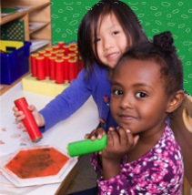
:: Monday – SEPTEMBER 14th

Learning
At Montessori :: The teacher assesses what the child has learned and then guides him into new areas of discovery.

At home:: Please remember to encourage fine motor skills TRY ~ Bead stringing, cutting, gluing, painting using a thin paint brush, drawing with colored pencils suggestions you can use with them at home for their continued writing development.

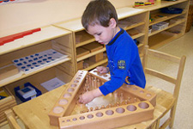
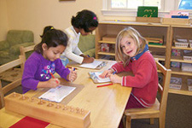
Reminders Kindergarten Parents
Please have your child bring a backpack to school each day they are here. We would like to get them in the habit of putting their work in them each day so they are prepared for next year. Remember, the PM session gets them use to having lunch in school and to get them adjusted to a full day at school.

Learning Center – Back to School

by Karen & Staff
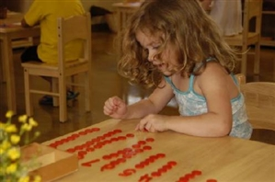
At home
When you encourage your child to participate in the curriculum, you are showing them you are aware of some of the activities and this could create an understanding in your child that will encourage them to fill you in on more of their day.

FUN FACTS

:: In our classroom most of the child’s day is spent in self-chosen work
:: The largest high school in America has over 8000 students. Our students will be counting that high!
:: 67% of kids like school ours 99.9%

For More Information
Contact us directly if ever you have a concern regarding your child’s education.

Bayport: 631-419-6239

Follow us @montessori_BBP

Montessori believes in following the child. So the child chooses what he wants to learn and the teacher guides the learning.

Back to school is an adjustment. If there are tears, remember child’s tears are natural. The process is also a natural one that we all have experienced before and we will give them the comfort they need. Parents we encourage you to review these books, crafts and activities. Prepare your child for an exciting school year. Have fun!

Craft: Capture their first day of school
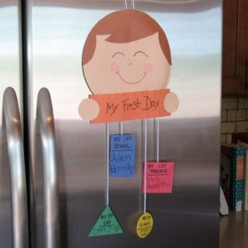
What You Need:

- Paper
- String
- 4 pennies
- Glue
- Paper plate
- Safety scissors

What You Do:

Cut shapes and add “my First Day-”, “My First School-”, “My First Lunch-”, “My First Teacher-” glue the string and pennies

Read more: http://spoonful.com/back-to-school/my-first-day-of-school/11437

Web Site Fun:
- Craft ideas Peekaboo Apple Paper Plate http://crafts.kaboose.com/peekaboo-apple-paper-plate.html
- Coloring Pages http://www.tlsbooks.com/preschoolcoloringpages.htm
- Songs:: IT’S THE FIRST DAY OF SCHOOL http://www.preschoolexpress.com/music-station08/1st-day-school-aug-sept08.shtml
Books:
The Kissing Hand By Audrey Penn
Chester Raccoon seeks love and reassurance from his mother as he ventures out into the world to attend his very first day of school
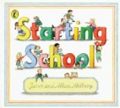
Starting School By Janet Ahlberg, Allan Ahlberg
This story describes what going to school entails. It aims to calm anxieties and encourage the enthusiasm of pre-school children
I Am Too Absolutely Small for School by Lauren Child
Lola is not so sure about school. After all, why would she need to count higher than ten when she never eats more that ten cookies at a time? Once again, it's up to ever-patient big brother Charlie to persuade Lola that school is worthwhile — and that her invisible friend, Soren Lorensen, will be welcome, too.
Check our web site for purchasing copies of these books
http://www.montessoripreschoolbayport.com/

