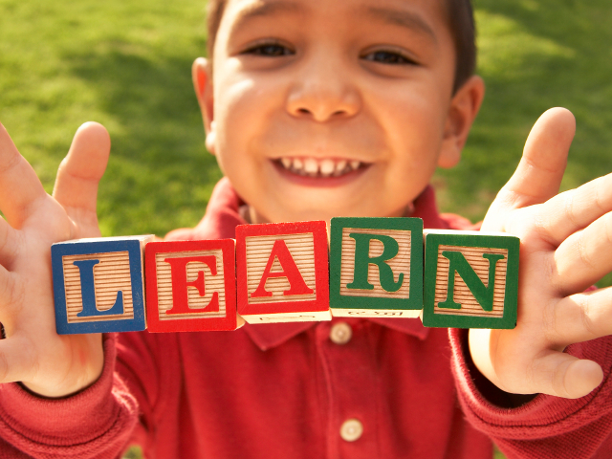 |  | - Montessori Learning Center  - Bayport  - Monthly News
Learning through experience |  | In This Issue
dD
Dear Parents,
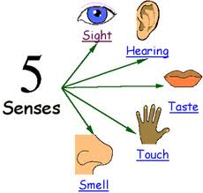
We have had a successful September. The children have been getting comfortable at school and with us and are already actively learning!

During the month of October, we will be learning about The Body, Our Senses and Halloween.

We encourage your child to participate during show and tell. Wednesdays are show and tell in the classroom. As a reminder, when choosing something to bring to school to share with their friends, has chosen something related to our curriculum.

We realize you are curious as to what they are specifically doing, we do keep records on them and will be going over all the details at our first Parent-Teacher conference scheduled for Tues November 2nd
If your child is still adjusting just remember to be positive, tell them they will have a lot of fun and to draw you a picture or make you a necklace.
This will show how your child you have confidence in them and in us, allowing them to also have that confidence.

NOTES
[Parent]
Our ONLINE BOOK FAIR is starting
October 18th
. All proceeds will go to purchase new books for the classroom.
[AFTERNOON SESSIONS]
We offer “drop in” sessions
fee $25.oo a day
Let us know that morning
TUE – WED – THU
Bring Lunch
Please remember you are always encouraged to ask us any questions you may have about how your child is doing. As always, it is our pleasure to have your children with us!
Karen & Staff
Reminder: Make arrangements for childcare - Parent Teacher Conference 11/07

The Body, Our Senses & Halloween

OCTOBER
:: CALENDAR REMINDER::

NO SCHOOL
:: OCTOBER 11th
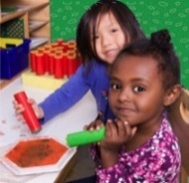

Learning
At Montessori :: The teacher assesses what the child has learned and then guides him into new areas of discovery.
At home:: Please remember to encourage fine motor skills TRY ~ Bead stringing, cutting, gluing, painting using a thin paint brush, drawing with colored pencils suggestions you can use with them at home for their continued writing development.

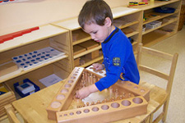
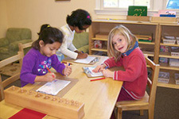
Reminders Kindergarten Parents
Please have your child bring a backpack to school each day they are here. We would like to get them in the habit of putting their work in them each day so they are prepared for next year. Remember, the PM session gets them use to having lunch in school and to get them adjusted to a full day at school.

Learning Center – The Body, Our Senses & Halloween

by Karen & Staff
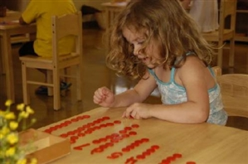
At home
When you encourage your child to participate in the curriculum, you are showing them you are aware of some of the activities and this could create an understanding in your child that will encourage them to fill you in on more of their day.

FUN FACTS

:: Nerve impulses to and from the brain travel as fast as 170 miles per hour
:: Sneezes regularly exceed 100 mph
:: After eating too much, your hearing is less sharp.
:: Your nose can remember 50,000 different scents

For More Information
Contact us directly if ever you have a concern regarding your child’s education.

Bayport: 631-419-6239

Follow us @montessori_BBP

Montessori believes in following the child. So the child chooses what he wants to learn and the teacher guides the learning.
The students are familiar with the routine of the day and we are looking forward to leading them into more and more challenging “work”. This month we are focusing on the Body, our senses and Halloween below are some suggestions for bringing the classroom home.

Craft: Sense of SMELL
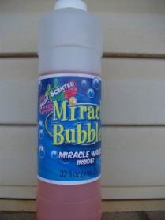
What You Need:

- Cotton Ball
- Bottles
- Scents

Things work
Garlic, Most spices
Scented oils,Perfumes
Vinegar, Lemon juice, Scented lotions
Fruit extracts, Coffee beans or grounds
Fresh grass clippings, Strongly scented flowers
Potpourri
What You Do: Smelling jars can be a wonderful learning experience for kids. It helps develop their senses and learn to use more than just their eyes when solving problems. These activities challenge children to identify smells, sort scents, and match smells.Web Site Fun:
- Games Ghoulish Halloween Games http://spoonful.com/halloween/ghoulish-halloween-games-gallery
- Coloring Pages Hallloween
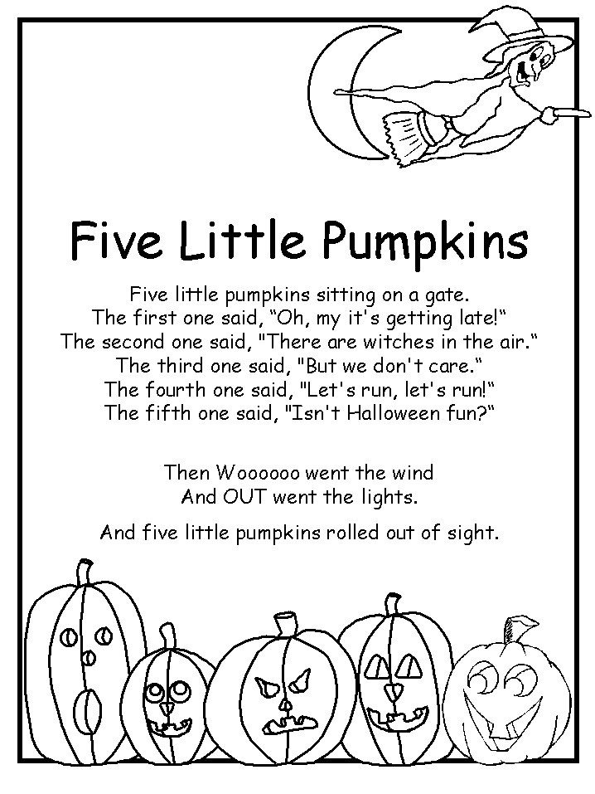
http://www.coloring.ws/halloween.html
- Songs:: Five
Little Pumpkins
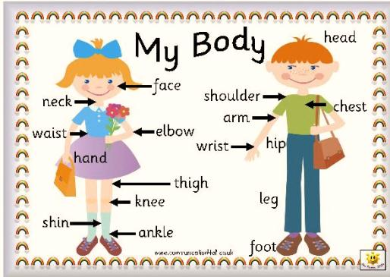
Books:
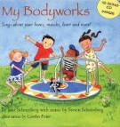
My Bodyworks: Songs About Your Bones, Muscles, Heart And More!
By Jane Schoenberg, Steven Schoenberg, Cynthia Fisher

Young children will discover how their bodies work when they read and sing along with fun and fact-filled songs.

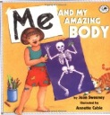
Me and My Amazing Body
By Joan Sweeneyg

From your head to your toes and everything in between, this playful introduction to anatomy explains all the important parts of your body.
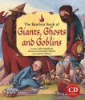
The Barefoot Book of Giants, Ghosts and Goblins
Encounter a whole host of outlandish characters in these nine stories gathered from cultures around the world. Action-packed and full of wonder, this anthology proves that everyone has challenges to overcome — even giants who are twelve feet tall
Check our website for purchasing copies of these books

http://www.montessoripreschoolbayport.com/

