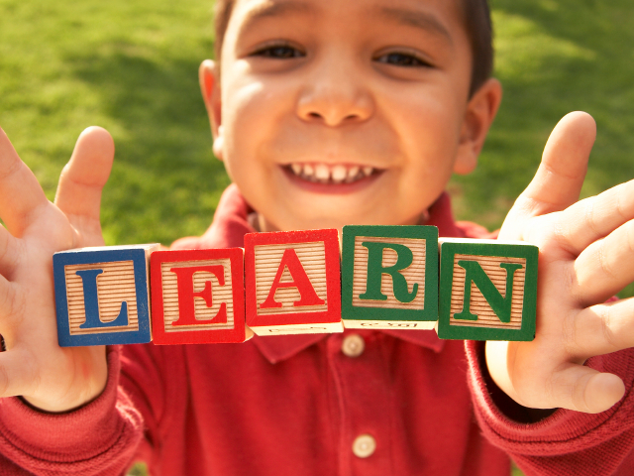 |  | - Montessori Learning Center  - Bayport  - Monthly News
Learning through experience |  | In This Issue

Dear Parents,

Native Americans, the Continents and Thanksgiving
The Children enjoyed learning about their senses and their bodies in October!

During the month of November, we will be learning about Native Americans, the Continents and Thanksgiving.
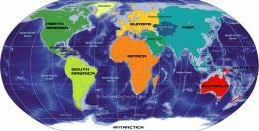
We encourage your child to participate during show and tell. Wednesdays are show and tell in the classroom. As a reminder, when choosing something to bring to school to share with their friends, has chosen something related to our curriculum.

With winter time fast approaching, please make sure your child’s jacket and book bags are clearly labeled with their names. Also, have your child take a look at their belongings each morning. They have been having trouble remembering their own jackets and book bags. If they know which is theirs, it will help them find their coats with confidence at dismissal time. This is also a good time of year for your child to practice putting their coat on and off themselves.
We realize it is faster and sometimes easier for adults to do this for the children, just remember the terrific self-satisfaction you will allow them to develop by encouraging tasks they are able to do for themselves. Each time we do something for a child it says to them, “You are unable to do this for yourself.” Encourage them to hang their coat themselves at school so they know where to look for it at the end of the school day.
NOTES
[Parent]
PARENT TEACHER CONF NOV 8th
WED 11/23 NO PM CLASSES
NO SCHOOL 11/24 & 11/25

[AFTERNOON SESSIONS]
We offer “drop in” sessions
fee $25.oo a day
Let us know that morning
TUE – WED – THU
Please Bring Lunch

Please remember you are always encouraged to ask us any questions you may have about how your child is doing.

As always, it is our pleasure to have your children with us!
Karen & Staff
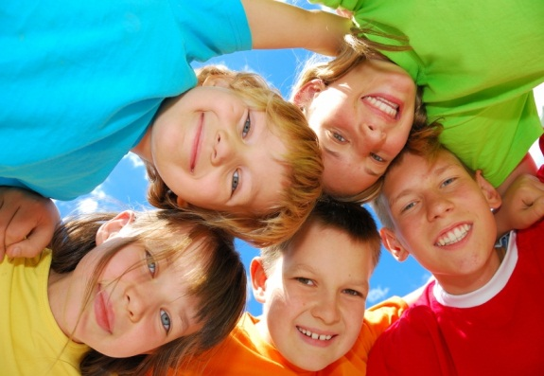

NOVEMBER :: CALENDAR REMINDER::
NO SCHOOL
-November
8,11 & , 24,25
November 23rd -NO PM CLASSES

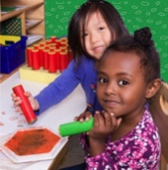

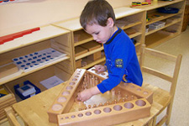
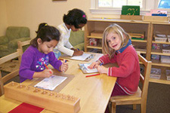
Reminders Kindergarten Parents
Please have your child bring a backpack to school each day they are here. We would like to get them in the habit of putting their work in them each day so they are prepared for next year. Remember, the PM session gets them use to having lunch in school and to get them adjusted to a full day at school.

Learning Center – Native Americans, the Continents and Thanksgiving by Karen & Staff
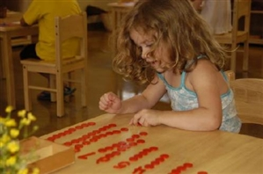
At home
When you encourage your child to participate in the curriculum, you are showing them you are aware of some of the activities and this could create an understanding in your child that will encourage them to fill you in on more of their day.

FUN FACTS

:: The highest mountain Mt Everest is in Asia
:: 98% of Antarctica is covered by ice
:: The heaviest turkey ever raised was 86 pounds, about the size of a large dog.
:: The first Thanksgiving celebration lasted three days

For More Information
Contact us directly if ever you have a concern regarding your child’s education.

Bayport: 631-419-6239

Follow us @montessori_BBP

Montessori believes in following the child. So the child chooses what he wants to learn and the teacher guides the learning.
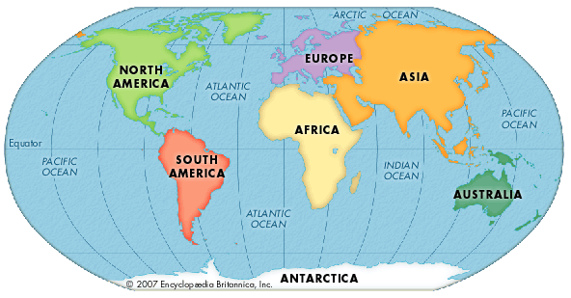
The students are familiar with the routine of the day and we are looking forward to leading them into more and more challenging “work”. This month we are focusing on Native Americans, the Continents and Thanksgiving below are some suggestions for bringing the classroom home.

Craft: Felt Continent map

What You Need:

- Hard felt in different colors
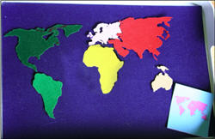
- Blue marker
- Map file:

Links to Maps found at
http://www.childandme.com

What You Do: How do you use these? As your kid is laying out the felt continents, he can add labels (continent names) and check himself by looking at those cards that you just created, where he has a continent shape and its name. Or he can just match the felt shape to the card. Or… you can come up with more ideas!

Web Site Fun:
- Games apples4theteacher has Native American Games
- DLTK's Crafts for Kids:: Turkey Crafts http://www.dltk-holidays.comatic
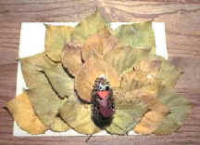

Books:
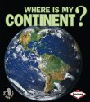

Where Is My Continent?
by Robin Nelson

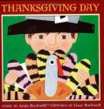
Thanksgiving Day
by Anne Rockwell

.

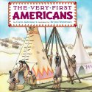
The Very First Americansby Cara Ashrose

Check our website for
purchasing copies of these books

http://www.montessoripreschoolbayport.com/

