  - Montessori Learning Center

  - Bayport

  - Monthly News

Learning through experience |  | In This Issue

Dear Parents,
During the month of May, our curriculum focuses on COMMUNITY! We will be learning about all of our community helpers. This month we will also be having some visitors to school, a policeman and a fireman.

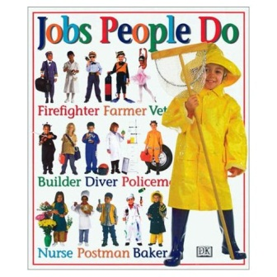
We encourage your child to participate during show and tell. Last month all the children did such a great job! As a reminder, when choosing something to bring to school to share with their friends, has chosen something related to our curriculum. It could be a book, picture, stuffed animal, plastic figure, etc.

Ask your child if they would like to do a project based on the curriculum and ask them what they would like to do. You can ask what materials they would like to use. Since the children have seen other projects, they now have a base of
knowledge to use as a starting off point for a project of their own.

An activity they have put a great deal of thought and effort into will give them a great deal of satisfaction leading to the confidence and self-esteem they will use throughout their future.
A Few Reminders:

Memorial Day
- School is CLOSED
- May 27 & 30th
^{Return 6/21 to the classroom}
**ALL REGISTRATION FOR 2022-2023 SCHOOL YEAR IS DUE

Thanks and as always it’s a pleasure teaching your child(ren).
Miss Karen and Staff

A Walk in the Neighborhood
MAY
Happy
Memorial Day Weekend
^{School Closing}
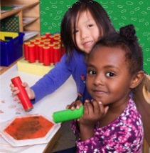
May 27th & 30th ^{t}

Learning
At Montessori :: The teacher assesses what the child has learned and then guides him into new areas of discovery.
At home:: Please remember to encourage fine motor skills TRY ~ Bead stringing, cutting, gluing, painting using a thin paint brush, drawing with colored pencils suggestions you can use with them at home for their continued writing development.
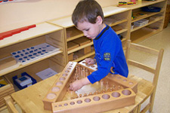
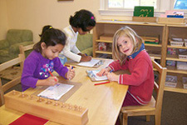
Reminders Kindergarten Parents
Please have your child bring a backpack to school each day they are here. We would like to get them in the habit of putting their work in them each day so they are prepared for next year. Remember, the PM session gets them use to having lunch in school and to get them adjusted to a full day at school.

Learning Center – Community Helpers

by Karen and staff
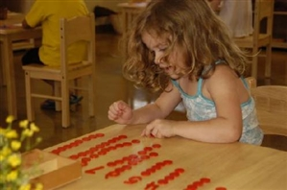
At home
When you encourage your child to participate in the curriculum, you are showing them you are aware of some of the activities and this could create an understanding in your child that will encourage them to fill you in on more of their day.

FUN FACTS

:: A "pipe man" or "nozzle man" is a firefighter who's job is to put water on the fire or the wet stuff on the red stuff.
:: Each American consumes, on average, 53 pounds of bread per year.
:: 12 - Twelve busy little bees must collect the nectar from 2,000 flowers to make a tablespoon of honey.
Check our web site for purchasing copies of these books
http://www.montessoripreschoolbayport.com/

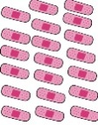
Fine Motor Building Skill: Community Helper Band Aid Counting Game
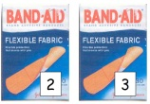
Cut the band aids, and the band aid boxes. Cut out the laminated band aids and boxes. Tape the boxes inside the file folder, leaving the top of the boxes open.-, to make a pocket. Place the band aids inside the file folder, and ask the children to try and put the number of band aids in the corresponding boxes.
*See Facebook for link to activity

For More Information
Contact us directly if ever you have a concern regarding your child’s education.

Bayport: 631-419-6239

Follow us @montessori_BBP

Montessori believes in following the child. So the child chooses what he wants to learn and the teacher guides the learning.
Our students are impacted daily by their community, whether they wave to the mailman or search for distant sirens. They interact with teachers, bakers and chefs on a regular basis, not realizing what special gifts they receive from each individual.
Below are some great activities and books for you and your family to review. Remember, to talk about our classroom sessions with your child along with doing some home activities.

Craft: Policeman Badge
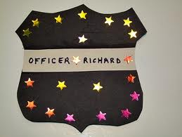
What You Need:

- Paintbrush
- CardBoard
- Paper
- Aluminum Foil

What You Do:
Cut out badge shapes out of the cardboard. Next cover the cardboard with Aluminum foil. Finally the kids can use the non-brush side of a paint brush to etch a badge into the aluminum foil.

Web Site Fun:
- Community Helper Craft ideas :: http://www.everythingpreschool.com/themes/helpers/art.htm
- Coloring Pages http://www.everythingpreschool.com/themes/helpers/coloringpage.php
- Songs:: http://www.preschooleducation.com/shelper.shtml
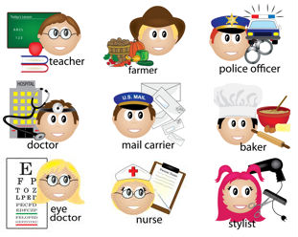
Books:
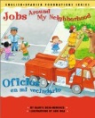
Jobs Around My Neighborhood bBy Gladys Rosa-Mendoza A fun learning book in English and Spanish depicts people engaged in a wide variety of useful occupations and tells the reader what each person does.
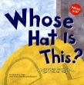
Whose Hat Is This?: A Look at Hats Workers Wear - Hard, Tall, and Shiny (Whose Is It?) By Katz Cooper, Sharon Describes some of the different kinds of hats that people wear.
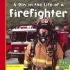
A Day in the Life of a Firefighter By Heather Adamson Children will explore a typical day of a community worker, following a firefighter as he puts out a fire, a construction worker on a buidling site, and more!

