  - Montessori Learning Center

  - Bayport

  - Monthly News

Learning through experience |  | In This Issue

Dear Parents,
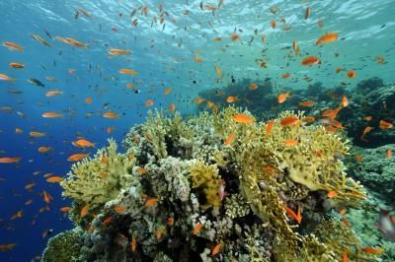
We hope you all had a nice few weeks with your children. We had the chance to get the school ready for your children’s return. We are looking forward to seeing them again and working with them! Welcome to all the new children and their parents!

During the month of July, we will be learning about all that takes place Under the Sea including the animals, the sea shells, the plants that live by the sea.

We encourage your child to participate during show and tell. As a reminder, when choosing something to bring to school to share with their friends, has chosen something related to our curriculum.

SUMMER SCHEDULE

9:30am – 12:30pm

WEEK 1 – June 29-July 1
WEEK 2 – July 6 -8
WEEK 3 – July 13-15
WEEK 4 – July 20-22
WEEK 5 – July 27- 29

Don’t forget to Bring Lunch

WED :: Show & Tell

Thanks and as always it’s a pleasure teaching your child(ren).

Enjoy the Summer Fun!
Karen and Staff

Under the Sea – What do you see?
SUMMER
:: REMINDER ::
SUMMER PROGRAM
9:30am – 12:30pm
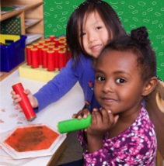
:: TUE – WED - THUR ::

Learning
At Montessori :: The teacher assesses what the child has learned and then guides him into new areas of discovery.
At home:: Please remember to encourage fine motor skills TRY ~ Bead stringing, cutting, gluing, painting using a thin paint brush, drawing with colored pencils suggestions you can use with them at home for their continued writing development.
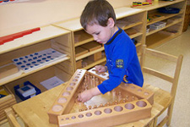
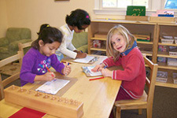
Reminders Kindergarten Parents
Please have your child bring a backpack to school each day they are here. We would like to get them in the habit of putting their work in them each day so they are prepared for next year. Remember, the PM session gets them use to having lunch in school and to get them adjusted to a full day at school.

Learning Center – Under the Sea

by Karen and Staff
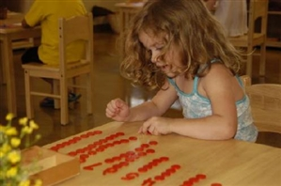
At home
When you encourage your child to participate in the curriculum, you are showing them you are aware of some of the activities and this could create an understanding in your child that will encourage them to fill you in on more of their day.

FUN FACTS

:: Dolphins sleep with one half of the brain at a time, and one eye open
:: Blue Whales weigh as much as 30 elephants and are as long as three Greyhound buses.
:: Shrimp can only swim backwards

For More Information
Contact us directly if ever you have a concern regarding your child’s education.

Bayport: 631-419-6239

Follow us @montessori_BBP

Montessori believes in following the child. So the child chooses what he wants to learn and the teacher guides the learning.

A wonderful world of incredible beauty and amazing facts lies in the sea. The astonishing detail truly, has fascinated many people around the world to the great depth of the sea. We are excited to talk about this section as we all have a chance to visit the beach this summer
Below are some great activities and books for you and your family to review. Remember, to talk about our classroom sessions with your child along with doing some home activities.

Craft: Colored Tape Fish

What You Need:

- Paper
- Colored masking tape
- Safety scissors

What You Do:

Children draw their own fish on a piece of paper. They tear off pieces of colored masking tape and stick them on for the fish’s gills.

Read more: http://prekinders.com/ocean-theme/#ixzz1wpRmeIIy

Web Site Fun:
- Craft ideas Fish Aquarium Craft Kit:: http://www.apples4theteacher.com/holidays/summer/kids-crafts/fish-aquarium-craft.html
- Coloring Pages http://www.apples4theteacher.com/coloring-pages/interactive-alphabet/letter-f/fish.html
- Songs:: Rub a Dub Dub http://prekinders.com/nurseryrhymes/RubaDubDub.pdf

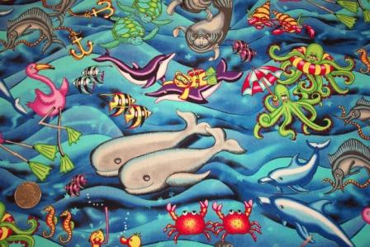
Books:
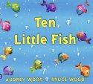
Ten Little Fish By Audrey Wood Undersea counting book that's full of the same vivid imagery and fun story elements

Amos & Boris by William Steig
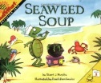
Amos the mouse and Boris the whale: a devoted pair of friends with nothing at all in common, except good hearts and a willingness to help their fellow mammal.
Seaweed Soup (MathStart 1) by Stuart J. Murphy
It's slimy. It's smelly. Its green and it's gooey. It's seaweed soup -- and its Turtle's favorite lunch.
Check our web site for purchasing copies of these books
http://www.montessoripreschoolbayport.com/

COOKING: Cup o' Fish
Make an edible aquarium in a cup. This is a great party treat you can make with your child.
- blue jello
- gummy fish (or fruit-flavored sharks)
- clear plastic cups.
*See Facebook for link to activity

