  - Montessori Learning Center

  - Bayport

  - Monthly News

Learning through experience |  | In This Issue

Dear Parents,
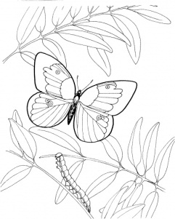
During the month of April, we will be learning about Plants, Flowers, springtime and we will be watching Caterpillars turn into Butterfly’s and more!

We encourage your child to participate during show and tell. Last month all the children did such a great job! As a reminder, when choosing something to bring to school to share with their friends, has chosen something related to our curriculum. It could be a book, picture, stuffed animal, plastic figure, etc.

Ask your child if they would like to do a project based on the curriculum and ask them what they would like to do. You can ask what materials they would like to use. Since the children have seen other projects, they now have a base of

knowledge to use as a starting off point for a project of their own.

An activity they have put a great deal of thought and effort into will give them a great deal of satisfaction leading to the confidence and self-esteem they will use throughout their future.

A Few Reminders:/New Notices
All forms for Fall/Summer registration are due
Graduation - FRIDAY JUNE 11th TBD
As always, it is our pleasure to have your children with us!
Karen & Staff

NOTES
[Parent]
[REMINDER]
For closings due to Snow (just in case we get more in this SPRING), we follow the Bayport/Blue Point School District

[AFTERNOON SESSIONS]
We offer “drop in” sessions
fee $25.oo a day Let us know that morning
TUE – WED – THU
Bring Lunch !

Plant Life & new beginnings
APRIL:: REMINDER::
:: School Closing ::
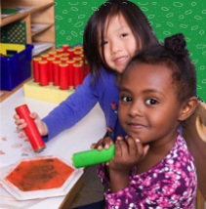
Tuesday April 6th School
Re-opens

Learning
At Montessori :: The teacher assesses what the child has learned and then guides him into new areas of discovery.
At home:: Please remember to encourage fine motor skills TRY ~ Bead stringing, cutting, gluing, painting using a thin paint brush, drawing with colored pencils suggestions you can use with them at home for their continued writing development.
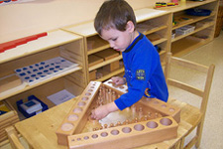
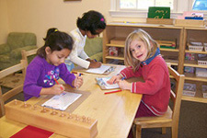
Reminders Kindergarten Parents
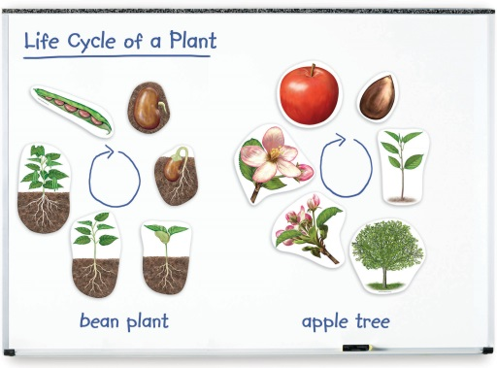
Please have your child bring a backpack to school each day they are here. We would like to get them in the habit of putting their work in them each day so they are prepared for next year. Remember, the PM session gets them use to having lunch in school and to get them adjusted to a full day at school.

Learning Center – PLANT LIFE

by Karen & Staff
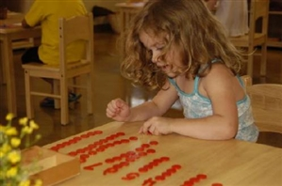
At home
When you encourage your child to participate in the curriculum, you are showing them you are aware of some of the activities and this could create an understanding in your child that will encourage them to fill you in on more of their day.

FUN FACTS

:: In spring, the Earth’s axis is tilted toward the sun, increasing the number of daylight hours.
:: Spring starts in September, October, and November in the Southern Hemisphere
:: Cooking at home in a pinch, tulip bulbs make a passably good substitute for onions in recipes

For More Information
Contact us directly if ever you have a concern regarding your child’s education.

Bayport: 631-419-6239

Follow us @montessori_BBP

Montessori believes in following the child. So the child chooses what he wants to learn and the teacher guides the learning.

Spring and "springtime" refer to the season, and broadly to ideas of rebirth, renewal and regrowth. Take time to look in your neighborhood and point out the new beginnings. Flowers, plants, animals and more.
Below are some great activities and books for you and your family to review. Remember, to talk about our classroom sessions with your child along with doing some home activities.

Craft: 'F' is for Flower – learn the different names for the parts of the flower as we put it together.
* toilet roll
* paint
* sticky tape
* green paper
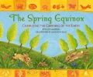
* egg carton
* tissue paper
* scissors
* fragrant oil (optional)
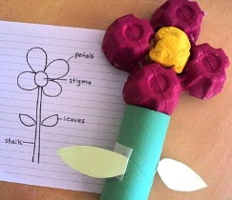
Idea from :: http://alittlelearningfortwo.blogspot.com/2010/11/f-is-for-flower.html

Web Site Fun:
- Spring Coloring Pages :: http://holidays.kaboose.com/spring-color.html

Books:
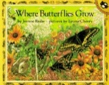
Where Butterflies Grow (Picture Puffins)
By Joanne Ryder
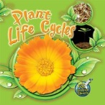
Plant Life Cycles (My Science Library, Levels 1-2) By Julie K. Lundgren

The Spring Equinox by Ellen Jackson Wonderful book about Spring. It goes through celebrations of spring from different cultures and different times.
Check our web site for purchasing copies of these books
http://www.montessoripreschoolbayport.com/

Fine Motor Building Skill: Egg transfer

The little eggs and baskets or you could also use jelly beans (but I knew ours would be gobbled up). Use a spoon to transfer the eggs from the bowl to the little basket. Count as you go. You can also do addition and subtraction using the baskets to hold different numbers of eggs. .

