  - Montessori Learning Center

  - Bayport

  - Monthly News

Learning through experience |  | In This Issue

Dear Parents,

Animals, Hibernation, Migration and Weather

We hope you all enjoyed the Holidays with your families! We are looking forward to seeing the children again and working with them. Traditionally, January has been a very productive month for the children. They are happy to be back at school after the Holiday break. They look forward to seeing their friends, teachers and getting back to their “work”.
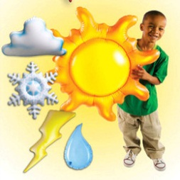
During the month of January, we will be studying about Animals, Hibernation, Migration and Weather. We encourage your child to participate during show and tell. Wednesdays are show and tell in the classroom. As a reminder, when choosing something to bring to school to share with their friends, has chosen something related to our curriculum.

Our program will continue with the Kindergartener’s coming together after circle time using the Language and Math materials. They are still all at different levels of development, however we are working with them as a group to have them prepared for Kindergarten.

Please encourage their success at home and please do not get too concerned about their skills.

Our younger children continue to work in all areas of the classroom at their own developmental levels.

To encourage them to express what they have done at school, ask them what “work” they did at school.

Please remember you are always encouraged to ask us any questions you may have about how your child is doing.

As always, it is our pleasure to have your children with us!
Karen & Staff

NOTES
[Parent]
[REMINDER]
For closings due to Snow, we follow the Bayport/Blue Point School District

[AFTERNOON SESSIONS]
We offer “drop in” sessions
fee $25.oo a day Let us know that morning
TUE – WED – THU
Don’t forget to Bring Lunch !

JANUARY
:: CALENDAR REMINDER::
NO SCHOOL
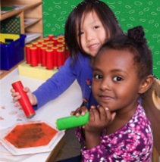
Jan 21st

LEARNING

At Montessori :: The teacher assesses what the child has learned and then guides him into new areas of discovery.
At home:: Please remember to encourage fine motor skills TRY ~ Bead stringing, cutting, gluing, painting using a thin paint brush, drawing with colored pencils suggestions you can use with them at home for their continued writing development.

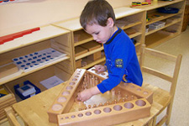
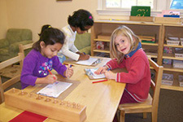
Reminders Kindergarten Parents
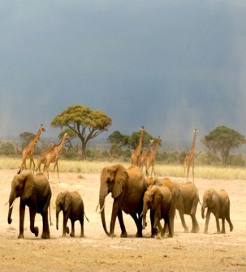
Please have your child bring a backpack to school each day they are here. We would like to get them in the habit of putting their work in them each day so they are prepared for next year. Remember, the PM session gets them use to having lunch in school and to get them adjusted to a full day at school.

Learning Center – Animals, Hibernation, Migration and Weather By Karen & Staff
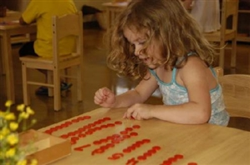
At home
When you encourage your child to participate in the curriculum, you are showing them you are aware of some of the activities and this could create an understanding in your child that will encourage them to fill you in on more of their day.

FUN FACTS

:: Most birds that migrate long distances fly at night.
:: The largest snowflakes in the world fell across Fort Keogh in Montana (USA) on 28 January 1887.
:: Despite the white, fluffy appearance of Polar Bears fur, it actually has black skin.

For More Information
Contact us directly if ever you have a concern regarding your child’s education.

Bayport: 631-419-6239

Follow us @montessori_BBP

Montessori believes in following the child. So the child chooses what he wants to learn and the teacher guides the learning.
The students are familiar with the routine of the day and we are looking forward to leading them into more and more challenging “work”. This month we are focusing on Animals, Hibernation, Migration and Weather below are some suggestions for bringing the classroom home.

Craft: Playful Penguins

What You Need:
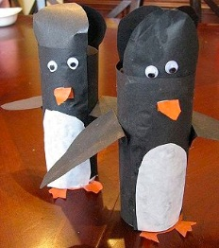
Materials:
- Cardboard toilet paper tube
- Black construction paper orange construction paper
- white construction paper
- googly eyes
- scissors
- glue
- pencil.

Links to craft found at
http://www.naturallyeducational.com/2011/01/penguin-toilet-paper-tube-craft/

Web Site Fun:
PINTEREST :: We found Winter Animals
Check out all of these fun crafts and books.
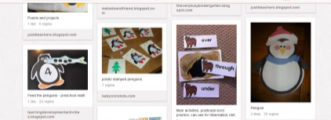
http://pinterest.com/mrspottsabc123/winter-animals-hibernation-migration-polar-arctic-/

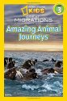
Books:

National Geographic Readers: Great Migrations Amazing Animal Journeys
By Laura Marsh

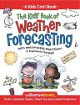
The Kids' Book of Weather Forecasting (Kids Can!)
By Breen, Mark, Friestad, Kathleen

.
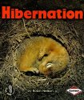
Hibernation (First Step Nonfiction)
By Robin Nelson

Check our website for
purchasing copies of these books

http://www.montessoripreschoolbayport.com/

