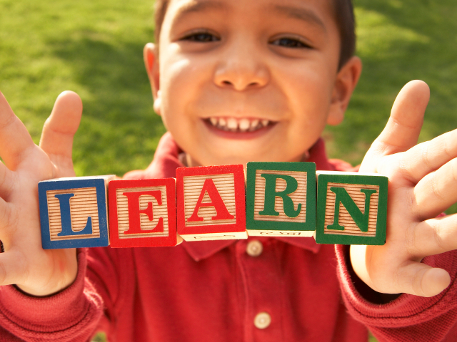 |  | - Montessori Learning Center  - Bayport  - Monthly News
Learning through experience |  | In This Issue

Dear Parents,

We have settled back to our daily routines and we enjoyed hearing about all the fun holiday activities you shared. This month our classroom is about to learn about the world of DINOSAURS.

We encourage your child to participate during show and tell. As a reminder, when choosing something to bring to school to share with their friends, has chosen something related to our curriculum. It could be a book, picture, stuffed animal, plastic figure, etc.

This is a great way for the program to come home and have you be a part of their school experience.

A SPECIAL NOTE TO
KINDERGARTEN PARENTS

Many of you have expressed an interest in extending your child’s day this spring; not only will it prepare your child physically for the longer day at school, away from you, we will have the opportunity for further Kindergarten work with them. We continue our class session after Lunch.

Experiencing Lunch gives your child the opportunity to get practice with their lunch boxes, opening their juice boxes, etc (this will come in handy in September)

While we do help them at this time, on how to set-up their lunches and explain there will be a lot of children in the big cafeteria at school. They enjoy the new experience.

Please call if you are interested in an extending day.

Also, please make sure to contact you’re school district about kindergarten registration and screening if you have not done so.

It is our pleasure to have your children with us!

Kind regards,
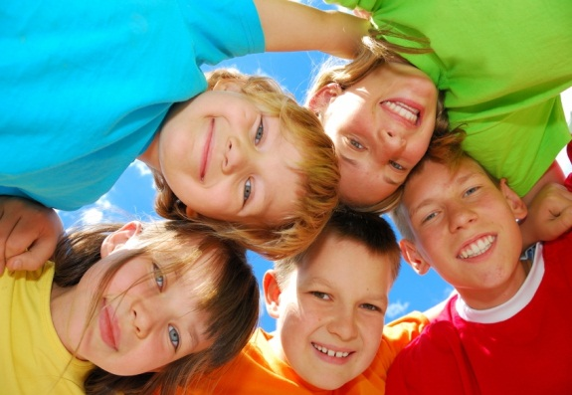
Karen & Staff

A Land Unknown & Lunch

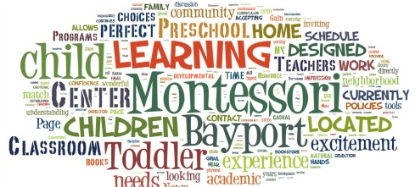

February
:: REMINDER – Mid Winter Break ::
February 17 – 21st
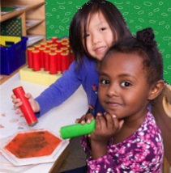
:: School Closing ::

Learning
At Montessori :: The teacher assesses what the child has learned and then guides him into new areas of discovery.At home:: Please remember to encourage fine motor skills TRY ~ Bead stringing, cutting, gluing, painting using a thin paint brush, drawing with colored pencils suggestions you can use with them at home for their continued writing development.
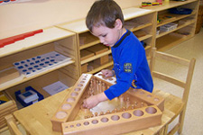
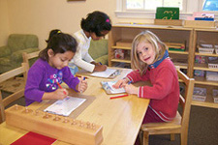
Reminders
For closings due to Snow, we follow the Bayport/Blue Point School District, In the event of a two-hour delay, we will be CLOSED. Please check with Channel 12 news in case of snow

Learning Center – Dinosaurs

by Karen & Staff
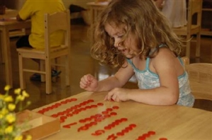
At home
When you encourage your child to participate in the curriculum, you are showing them you are aware of some of the activities and this could create an understanding in your child that will encourage them to fill you in on more of their day.

FUN FACTS

::The smallest known dinosaur is Compsognathus.
::Scientists aren't sure what color Dinosaur were.
::Jellyfish as a species are actually older than Dinosaur and Shark.

For More Information
Contact us directly if ever you have a concern regarding your child’s education.
Bayport: 631-419-6239

Follow us @montessori_BBP

Montessori believes in following the child. So the child chooses what he wants to learn and the teacher guides the learning.
February we explore Dinosaurs. From slow, plant-eating giants to fierce scavengers and hunters, dinosaurs dominated the land for over 160 million years.
Below are some great activities or books review for you to talk about with your child along with some books and home activities.

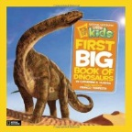
Craft: Fossils
Have fun with your child making a replica of a dinosaur fossil.
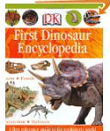
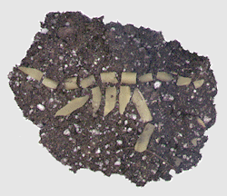
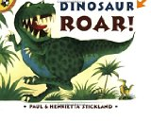
Visit: http://www.makingfriends.com/educational/dinofosl.htm

Web Site Fun:

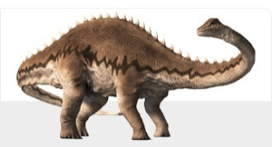
This site has a great time line with pictures of dinosaurs that lived during that era. Also, it has a link for dinosaurs that lived in our country.
http://www.nhm.ac.uk/nature-online/life/dinosaurs-other-extinct-creatures/dino-directory//top-5.dsml
or http://www.dinodictionary.com/
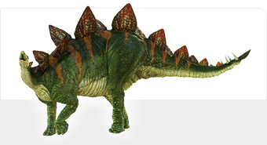
Books:

National Geographic Little Kids First Big Book of Dinosaurs
First Dinosaur Encyclopedia by Caroline Bingham

Dinosaur Roar (Picture Puffins) by Paul Stickland and Henrietta Stickland

Practical Life Skills: The Dinosaur Washing Tray. Here is what you will need:
One large dinosaur figure
Tray or shallow box
Bowl for water
Jug of water-put in just enough water so the bowl won't overflow
Face or wash cloth
Cotton swabs
Child's soft, new toothbrush

Put items on tray and bring to the table. Show how to slowly fill the bowl about 1/3 with water. Take the brush and slowly clean the dinosaur model. Dry with cloth. Use cotton swab to dry smaller areas, such as claws and head. Put everything away when finished.

