  - Montessori Learning Center

  - Bayport

  - Monthly News

Learning through experience |  | In This Issue

Dear Parents,

WINTERTIME AND HOLIDAYS

The Children enjoyed learning about Native Americans, the Continents and Thanksgiving in November!

During the month of December, we will be learning about wintertime and holidays.
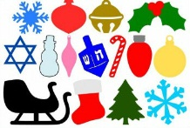
We encourage your child to participate during show and tell. Wednesdays are show and tell in the classroom. As a reminder, when choosing something to bring to school to share with their friends, has chosen something related to our curriculum.

Please remember you are always encouraged to ask us any questions you may have about how your child is doing.

As always, it is our pleasure to have your children with us!

Karen & Staff

NOTES
[Parent]
Holiday Party

Thursday December 22nd from 10 -11:30
we will be keeping our guests to parents and siblings only please

[AFTERNOON SESSIONS]
We offer “drop in” sessions
fee $25.oo a day Let us know that morning
TUE – WED – THU
Bring Lunch for your childl

A Special
Holiday Message
from our staff

Warmest thoughts and best wishes for a wonderful holiday and a very Happy New Year.

DECEMBER
:: CALENDAR REMINDER::
NO SCHOOL
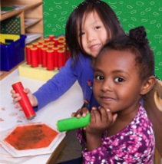
Dec 23 – Jan 2nd

School Re-opens
Tuesdaty Jan. 3rd

LEARNING

At Montessori :: The teacher assesses what the child has learned and then guides him into new areas of discovery.
At home:: Please remember to encourage fine motor skills TRY ~ Bead stringing, cutting, gluing, painting using a thin paint brush, drawing with colored pencils suggestions you can use with them at home for their continued writing development.

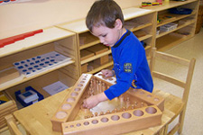
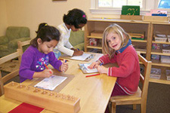
Reminders Kindergarten Parents
Please have your child bring a backpack to school each day they are here. We would like to get them in the habit of putting their work in them each day so they are prepared for next year. Remember, the PM session gets them use to having lunch in school and to get them adjusted to a full day at school.

Learning Center – WINTERTIME AND HOLIDAYS

By Karen & Staff
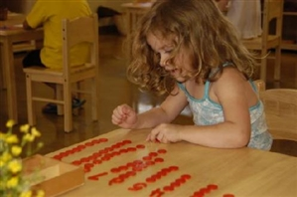
At home
When you encourage your child to participate in the curriculum, you are showing them you are aware of some of the activities and this could create an understanding in your child that will encourage them to fill you in on more of their day.

FUN FACTS

:: Snowflakes are ice crystals that form in the clouds.
:: The winter solstice takes place when the earth's axis is furthest away from the sun, or at 23 degrees 26'.
:: More than 150 million chocolate Santas will be made for the winter holiday season

For More Information
Contact us directly if ever you have a concern regarding your child’s education.

Bayport: 631-419-6239

Follow us @montessori_BBP

Montessori believes in following the child. So the child chooses what he wants to learn and the teacher guides the learning.
The students are familiar with the routine of the day and we are looking forward to leading them into more and more challenging “work”. This month we are focusing on WINTERTIME AND HOLIDAYS below are some suggestions for bringing the classroom home.

Craft: Paper Dreidel

What You Need:
- 8-1/2x8-1/2-inch square of paper
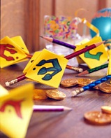
- Hole punch
- Marker
- Double-face tape
- Pencil
- Staple

Links to craft found at
http://www.lhj.com/relationships/family/crafts/paper-dreidel-craft/

Instructions:
Make dreidel shape. Fold the square of paper into quarters. Open up the shape. Paper-punch a hole in the center of the paper. Fold the corners of the square into the center. Flip the shape over, and fold the corners into the center again. Flip the shape over. Draw the Hebrew letters Nun, Gimel, He, and Shin (see next page) on the four squares. More detail on website.

Web Site Fun:
- DLTK's Crafts for Kids:: Christmas Handprint and Footprint Rudolf http://www.dltk-holidays.com/xmas/index.html

Books:
A Wish to Be a Christmas Tree
By Colleen Monroe

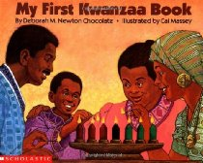
My First Kwanza Book
By Deborah Chocolate, Deborah M. Newton Chocolate

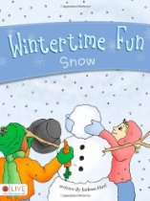
.
Wintertime Fun
By Joelean Harl

Check our website for
purchasing copies of these books

http://www.montessoripreschoolbayport.com/

